Contents:
- Executive summary
- Introduction
- Purpose of the study
- Scope of the study
- Objectives of the study

Executive summary
Financial statements provide summarized view of the financial position and operation of the company. Many parties are interested in financial statement analysis to know about the financial position of the firm. They include investors, creditors, lenders, suppliers etc. Ratio analysis is the widely used tool of financial analysis. It is the systematic use of ratios to interpret the financial statements so that the strengths and weaknesses of a firm is determined.
Title:
Analysis of financial performance on the basis of financial ratios at B.D.K. process control private Ltd. Hubli

Project consists of analysis of financial performance on the basis of financial ratios
The study will reveal the financial performance of the firm which enables the management to know their financial strengths of the firm to make their best use.
Study will also help to spot out financial weaknesses of the firm if any and to take suitable corrective actions.
The other objectives of this study are also find out liquidity position, profitability, efficiency of the B.D.K. Process Control Private Ltd.
For this purpose balance sheet of recent three years is taken and analyzed with the help of various financial ratios.
Based on this analysis, observations, given personnel will be taking corrective actions to improve the performance.

OBJECTIVES OF THE STUDY
- Main Objective is to study the different ratios used in B.D.K Process Control Private Ltd.
- To know the financial performance based on ratios.
- To pinpoint the direction with which the organization is moving.
- To know the financial position of the B.D.K. Process Control Private Ltd.
- To know the liquidity position of the B.D.K. Process Control Private Ltd.
- To assess the long-term viability of the firm.
- To know the efficiency in the management and utilisation of its assets.
Findings:
- The company is enjoying the profit during the period of study.
- Liquidity position of the company is increasing.
- The company is having more internal funds.
- The debtor collection period is increasing.
- The company is enjoying better credit period.
Suggestions:
- The company has to reduce its investments in current assets.
- The company has to maintain proper debt equity combination.
- Company should improve its credit policy for the better management of credit and to earn more profit.

ITRODUCTION
Ratio analysis:
Ratio analysis is a widely used tool of financial analysis. It is defined as the systematic use of ratios to interpret the financial statements so that the strengths and weaknesses of a firm as well as its historical performance and current financial can be determined. The rationale of ratio analysis lies in fact that it makes related information comparable. A single figure by itself has no meaning but when expressed in terms of related figure, it yields significant inferences.

Meaning and definition
A Ratio is defined as “the indicated quotient of two mathematical expressions” and “as the relationship between two or more things”.
In financial analysis, a ratio is used as benchmark for evaluating the financial position and performance of a firm.
The term ratio refers to the numerical or quantitative relationship between two items/variables.
This relationship can be expressed as:
- Percentages
- Fractions
- Proportion of numbers

Basis for comparison
Comparison with related facts is, therefore, the basis of ratio analysis. Four types of comparisons are involved
- Trend analysis
- Inter-firm comparison
- Comparison of items within a single year’s financial statement of the firm
- Comparison with standards or plans
Trends ratios involve a comparison of ratios of a firm over a time, that is, present ratios are compared with past ratios for the same firm.
The inter-firm comparison involving comparison of ratios of firm with those of others in the same line of business or for the industry as a whole, reflects its performance in relation t its competitors.
Other types of comparison may relate to comparison of items within a single year’ financial statement of a firm and comparison with standards or plans.

Types of ratios (Purpose-Wise classification):
Ratios can be classified, for purposes of exposition, into three broad groups
- Profitability ratios.
- Turnover (activity) ratios.
- Financial ratios

1. Profitability Ratios
Purpose: To indicate how successfully a firm is run.
Interested parties:
- Shareholders (actual and potential)
- Potential takeover bidders
- Lenders
- Competitive firms
- Management
Ratios to be used:
  - Gross Profit Ratio
  - Net Profit Ratio
  - Operating Expenses Ratio
  - Operating Profit Ratio
  - Return On Investment / Overall Profitability Ratio
  - Return On Equity
  - Return On Total Assets
  - EPS
  - DPS

2.Turnover ratios
Purpose: To know the managerial efficiency, these ratios indicates profitability, use of assets, capital structure analysis etc.
Interested parties:
- Shareholders (actual and potential)
- Potential takeover bidders
- Management
Ratios to be used:
- Inventory stock turnover Ratio
- Debtors (Accounts Receivable) Turnover Ratios.
- Creditors (Account Payable) Turnover Ratios
- Fixed Assets turnover Ratio
- Current Assets turnover Ratio
- Working capital turnover Ratio
- Total Assets turnover Ratio
- Net Assets turnover Ratio

3. Financial Ratios
Purpose: These ratios indicate short term and long-term liquidity and solvency of the firm. These ratios indicate the ability of the firm to survive over a long period of time after meeting its commitment in the form of interest and maturing debts.

Interested parties:
- Short-term & long-term creditors
- Banks & Debenture holders
- Shareholders
- Management
Ratios to be used:
- Financial Ratio:
Current Ratio
Quick / Acid test / Liquid Ratio.
Absolute liquid / Cash Ratio
- Leverage Ratio:
Debt ratio
Debt equity Ratio
Proprietary Ratio
Interest coverage Ratio

IMPORTANCE AND LIMITATIONS OF RATIO ANALYSIS
IMPORTANCE
Liquidity Position: With the help of ratio analysis conclusions can be drawn regarding the liquidity position of a firm. A firm can be said to have the ability to meet its short-term liabilities if it has a sufficient liquid funds to pay the interest on its short-maturing debt. This ability is reflected in the liquidity ratios of a firm. The liquidity ratios are particularly useful in credit analysis by banks and other suppliers of short-term loans.

Long-term Solvency: Ratio analysis is equally useful for assessing the long-term financial viability of a firm. This aspect of the financial position of a borrower is of concern to the long-term creditors, security analysis, and the present and potential owners of the business. The long-term solvency is measured by the leverage/capital structure and profitability ratios, which focus on earning power and operating efficiency.
Operating Efficiency: Yet another dimension of the usefulness of ratio analysis, relevant from the viewpoint of management, is that it throws light on degree of efficiency in the management and utilization of its assets. The various activity ratios measure this kind of operational efficiency.
Overall profitability: The outside parties, which are interested in one aspect of the financial position of a firm, the management is constantly concerned about the overall profitability of the enterprise. That is, they are concerned about the ability of the firm to meet its short-term as well as long-term obligations to its creditors, to ensure a reasonable return to its owners and secure optimum utilization of the assets of the firm.
Inter-firm Comparison: One of the popular techniques is to compare the ratios of a firm with the industry average. It should be reasonably expected that the performance of a firm should be in broad conformity with that of the industry to which it belongs. An inter-firm comparison would demonstrate the relative position vis-à-vis its competitors.
Trend Analysis: It enables us to know whether the financial position of a firm is improving or deteriorating over the years. This is made possible by the use of trend analysis.

LIMITATIONS
If companies ignore the impact of inflation or price level changes in the financial statements or if financial statements are based on historical costs. Then it becomes limitation of ratio analysis. Another problem is it depends on quality of financial statements. For example: if there is no transparency / disclosure of real things in the statements it becomes problem to analyst. But now days it doesn’t hold well. Because, every company has to disclose it’s information according to accounting standards, in the annual reports.

Statement of the problem:
The company wants analysis of its financial performance and compare its performance of past with the present performance with the help of ratio analysis, in order to know the financial strengths of the firm to make their best use and to be able to spot out financial weaknesses of the firm.
Research problem:
To know the Financial Position of the company and its Liquidity Performance through comparing three years financial performance by applying different financial Ratios.
Purpose of the study:
- The study will pinpoint the direction with which the organization is moving.
- The study will also help to know the operating performance of the company.
- The study will reveal the credit worthiness of an enterprise and financial position of the firm.
Scope of the study:
The scope of the study is conducted is only for organization level. It is done through Balance Sheet of Company. For a period 2003-04, 2004-05, 2005-06

Objectives of the study:
- Main Objective is to study the different ratios used in B.D.K Process Control Private Ltd.
- To know the financial performance based on ratios.
- To pinpoint the direction with which the organization is moving.

- To know the financial position of the B.D.K. Process Control Private Ltd.
- To know the liquidity position of the B.D.K. Process Control Private Ltd.
- To assess the long-term viability of the firm.
- To know the efficiency in the management and utilization of its assets.

Contents:
- Organization Profile
- Organization chart
- Research design
- Data collection methods
- Measuring tools

COMPANY PROFILE

FORMATION OF THE COMPANY

Khimji’s first manufacturing plant, established in 1961, broke new ground for providing a high-quality alternative to import of valves and pumps, while assuring availability of spare parts and excellent services.
Keeping pace with industrial growth, the B.D.K Group founded in 1978 by Bharat B. Khimji, the (US $21 million Group has been building on heritage of initiative and innovation at the service of industry, offering- along with its ten associate companies, a wide spectrum of Industrial valves and Industrial Process Pumps Designed for the needs of chemical and Petrochemicals industries.
In the year 1980 it has merged into one company with name B.D.K Group of companies, which has B.D.K Process control Pvt. Ltd. Company. And in 1984 with name B.D.K Engineering Industries is commenced.
The company is located on 27 acres of land in Gokul road, Hubli. B.D.K Process Control Pvt. Ltd. is manufacturing the products like Diaphragm valves, Butterfly Valves, Plug valves, etc. B.D.K Engineering Industries Ltd. is manufacturing products like Globe valves, Check valves, Gate valves, Ball valves, etc.
The company is mainly catering industries like chemical process industries, refineries, petrochemicals and fertilizer plants, oil corporation, thermal and nuclear power plants, pharmaceuticals, food and beverage industries, water supply plant, mining industries, etc.

The company is selling its products in domestic as well as abroad market through
B.D.K. Marketing Services Pvt. Ltd. All over India it has 10 branches namely: Chennai, Mumbai, Culcutta, Delhi, Pune, Bangalore, Hydarabad, Baroda, Luknow, Indore.

BOARD OF DIRECTORS

* Mr. Bharat Kimji.
(CEO & founder of B.D.K group of companies)

* Mr. Sachin Kimji
(Director Of Manufacturing)

* Mr. Binoy Khimji,
(Director - International Business.)

* Mr. K. Sundaram
(Corporate business)

* Mr. M.B.Goudar
(Domestic sales)

* Mr. Srikant Kulkarni
(Head Exports)

ORGANIZATIONAL OBJECTIVES AND QULITY POLICY:
The name B.D.K is synonymous with quality. The objective of the organization is well defined in the companies’ quality policy, which is as under

Vision:
“To be the most admired company in the production of valves industry.”

Mission:
“To design, to manufacture to market quality product at competitive prices to the entire satisfaction of the customer and market leadership.”

Quality policy:
“The quality policy shall be to design to manufacture to market quality products at competitive prices to the entire satisfaction of the customer and to attain market leadership”

Organizational objectives:
- To strive for excellence in quality of their products in national and international market and to be recognized as leading players.
- To develop necessary competence at al levels of operations and improves the process, products and services to sustain quality reputation.

- To seek participation of employees at all levels of operation and to form a motivated team where they treat each other with mutual trust and respect.
- To shoulder social responsibility by maintaining a safe, clean and hygienic environment.

PRODUCTS OF B.D.K. GROUP OF COMPANIES
BDK Group from India manufactures and exports largest range of valves, pumps and other chemical industry products for all process handling needs
.
Valves | Others
Diaphragm | PTEE lined pipe
Butterfly | Actuators
Pfa lined | Auto Filters
Gate
Globe
Check
Ball
Forged steel
Knife Edged Gate

Production capacity:
BDK has an annual production capacity of manufacturing
- 100,000 Diaphragm and Butterfly Valves;
- 10,000 Cast Steel Gate, Globe & Check Valves;
- 50,000 Plug Valves;
- 80,000 Ball Valves;
- 80,000 Forged Steel Gate, Globe & Check Valves;
- 10,000 Special Purpose Valves
- 10,000 Custom-made Valves
- 5000 Process pumps.
BDK's speciality, along with a wide-ranging product line, is to manufacture Special Valves in Exotic materials.
STRENGTH
At BDK, People are selected and developed as rigorously as components in a complex piece of engineering - as in a way they are. Because it's their individual performance that adds up to the superior functioning of the entire organization and it's various activities (manufacturing, finance, marketing, research / development and HRD). More than 800 well-qualified engineers, technicians and administrative personnel bring their experience and skills to the requirements of the full developmental life cycle. Continuous

updating ensures a spirit of constant learning at BDK, that skills and knowledge are in tune with the time and more than equal to today's demands.
NEW DEVELOPMENTS
New Products
Innovation, Reinvention and Diversification are a continuous process at BDK.
Be it a new product development or enhancement of older products, we at BDK are constantly striving to give our customers maximum value for their investment, widest product range and most complete solutions.
Over the last few years BDK has been introducing new products on a regular basis, steam traps, strainers, air release valves and air filters to name a few. We are on the constant look for innovative products that complement the BDK Range. With our well-established network of sales offices and leading industry clientele, we have been able to successfully branch out and gain product acceptance for various ancillary products.
Travel Inn
From a traditional manufacturing company, BDK has diversified into the Hotel Industry by introducing its first 36-room hotel on the outskirts of HUBLI. Complete with open-air restaurant, bar, banquet facilities to conference facilities Travel Inn provides the necessary amenities for both the Business and Holiday traveler.
Pick 'N' Pay
The FMCG market is growing at an annual rate of 8% over the last 5 years and it is estimated to keep growing over at the same pace for the next decade. With a growing need for a one-stop shop convenience store, BDK recently launched two of the largest super market stores in HUBLI. Under the brand name of PICK 'N' PAY, BDK has taken its first step in to FMCG industry in India. The future plans are to franchise the PICK 'N' PAY brand name to different parts of India and establish itself as a leader in the super market industry.
Knownet
Multiple skills and competencies combine to realize technology-driven business transformation. As organizations constantly strive to iterate their business and IT strategies, Knownet’s well-honed capabilities and methodologies for IT services complement our business consulting services to define, optimize and align our clients' business strategy with technology initiatives.
Knownet is one of the premier solution providers of India. Our business interests vary into a wide gamut of activities ranging from Web Solutions, ERP Solutions, E-business Applications, CRM solutions, and IT Consultancy. Our portfolio of services has helped industry sectors like Shipping, Entertainment, Pharma, Manufacturing Logistics and Financial Institution.

B.D.K. PROCESS CONTROL
PRIVATE LIMITED
B.D.K. process control Pvt. Ltd., commenced its business in 1980 it is the largest manufacturer of diaphragm, butterfly and plug valves in the country and the market leaders. The company has grown steadily and its actual production during the year 2004-2005 it was 84,247 units, and it was raised to 92589 units during the year 2005-2006.
B.D.KPC has a documented quality system to meet the requirements of ISO:9001/1994 to ensure that its orders processed, products produced and services rendered meet the customer requirements. The unit has already accelerated to ISO 9001/1994 quality assurance standards by M/S. RWTUV.
Name : B.D.K.PC Pvt. Ltd.
Constitution : Pvt. Limited
Sales Head Quarters : Hubli
Registered office : Mumbai
Marketing Agents : B.D.K marketing services Pvt. Ltd.

Departments of B.D.K.PC Pvt. Ltd.:
B.D.K. Process Control Private Ltd. mainly has 7 departments. For each department, duties, responsibilities and authorities are assigned accordingly for the smooth running of all the activities.

Different departments are listed below:
- Time office
- Sale Co-Ordination
- Production Planning and Control
- Design and Development
- Materials and Stores
- Accounts
- Quality Assurance

ORGANIZATION CHART
BDK
GROUP OF
COMPANIES
BDK
Process control
Private Limited
BDK
Engineering
Industries
Limited
BDK
Marketing
Services
Limited
BDK
Sports Foundation
BDK
Travel Inn
And
Pick and Pay
Time
Office
Dept.
Quality Assurance Dept.
Design and
Development
Dept.
Material
Dept.
Accounts
Dept.
Production Planning
And
Control
Dept.

Sales
Coordination
Dept.

ORGANIZATION STRUCTURE

OF

ACCOUNTS DEPARTMENT
Executive
Director
ASST.
Finance Manager

Accounts Officer
Assistant Accountant
Assistant Accountant

Staff
Staff
Staff
Staff

DESIGHN OF THE STUDY
Title of the project:
“A study report on analysis of financial performance on the basis of financial ratio at B.D.K. Process Control Private Ltd.”
Statement of the problem:
The company wants analysis of its financial performance and compare its performance of past with the present performance with the help of ratio analysis, in order to know the financial strengths of the firm to make their best use and to be able to spot out financial weaknesses of the firm.
Research problem:
To know the Financial Position of the company and its Liquidity Performance through comparing three years financial performance by applying different financial Ratios.
Purpose of the study:
- The study will pinpoint the direction with which the organization is moving.
- The study will also help to know the operating performance of the company.
- The study will reveal the credit worthiness of an enterprise and financial position of the firm.
Objectives of the study:
- Main Objective is to study the different ratios used in B.D.K Process Control Private Ltd.
- To know the financial performance based on ratios.

- To pinpoint the direction with which the organization is moving.
- To know the financial position of the B.D.K. Process Control Private Ltd.
- To know the liquidity position of the B.D.K. Process Control Private Ltd.
- To assess the long-term viability of the firm.
- To know the efficiency in the management and utilization of its assets.
Scope of the study:
The scope of the study is conducted is only for organization level. It is done through Balance Sheet of Company. For a period 2003-04, 2004-05, 2005-06.
Data collection method:
The information necessary for this survey is collected by tapping primary & secondary source:
Primary sources: - Personal interviews with the officials of BDKPC Ltd.
Secondary sources: - 1) Annual reports of the BDKPC Ltd.
- Related information from Internet.
- Books and Publications.
Measuring tool:

- Accounting Ratios.
- Financial Statements of the Company

Limitations of the study:

- Researcher has taken only 3 years data of base for the analysis. Since, time is shorter in nature, it lacks in complete evaluation of the firm.
- The study is largely depending on secondary data, like Profit and Loss account, and Balance Sheet of the B.D.K. Process Control Private Ltd. For the related years.

Contents:
- Result &discussion with Charts & graphs
- Suggestions
- Conclusion

ANALYSIS
OF
PROFITABILITY RATIOS
OF THE
COMPANY

1.Profitability Ratios:
Apart from the creditors, short-term and long-term, also interested in the financial soundness of a firm are the owners and management of the company itself. The management of the firm usually eager to measure its operating efficiency. Similarly, the owners invest their funds in the expectation of reasonable return. The operating efficiency of a firm and its ability to ensure adequate return to its shareholders depends ultimately on the profits earned by it. The profitability of a firm can be measured by its profitability ratios.
Profitability ratios are:
  - Gross Profit Ratio
  - Net Profit Ratio
  - Operating Expenses Ratio
  - Operating Profit Ratio
  - Return On Investment / Overall Profitability Ratio
  - Return On Equity
  - Return On Total Assets
  - EPS
  - DPS

- GROSS PROFIT MARGIN RATIO:-
Gross profit is the difference between sales and the manufacturing cost of goods sold. And gross profit is compared with the sales. Gross profit margin ratio reflects the efficiency with which management produces each unit of product. This ratio indicates the average spread between the cost of goods sold and sales revenue. A high gross profit ratio is sign of goods management and implies that the firm is able to produce at relatively lower cost.
A low gross profit margin reflects higher cost of goods sold due to
- Reduction in selling price
- Inefficient utilization of plant and machinery etc.
It is calculated as follows:
Gross profit ratio= Sales-Cost of Goods Sold
____________________
Net Sales.

= Gross Profit * 100
___________
Net Sales

GROSS FROFIT RATIO
(Amount in Lakhs)
Year | 2003-04 | 2004-05 | 2005-06
Gross profit | 798.17 | 561.11 | 424.39
Net Sales | 1452.57 | 2026.13 | 2689.94
Gross Profit Ratio (%) | 29.217 | 27.693 | 29.672
SOURCE: ANNUAL REPORTS OF COMPANY

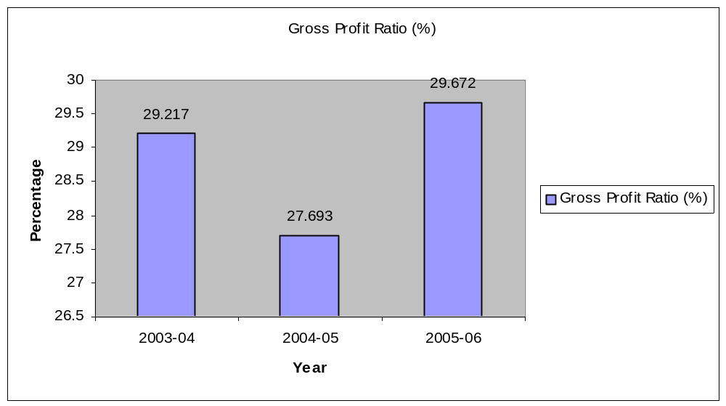
Interpretation: The table reveals that the ratio of gross profit to sales, the gross profit margin has varied in the range of 27.693% to 29.672% during the period of study. The ratio is quite constant and also it is increased in the year 2005-06, indicates the efficiency of management in manufacturing and trading operations.

2.NET PROFIT MARGIN RATIO OF TELCON
This ratio is also known as net margin. This measures the relationship between net profit and sales of a firm. Depending on the concept of net profit employed, it is calculated as follows
= Profit (loss) after tax
___________________ * 100
Net Sales

This ratio indicates company’s capacity to withstand adverse economic conditions.
A company with high net margin ratio would ensure adequate return to the owners as well as enable a firm to withstand adverse economic condition when selling price is declining, cost of production is rising and demand for the product is falling.
It would really be difficult for a low net margin ratio company to withstand these advantageous.
NET PROFIT RATIO
(Amount in Lakhs)
Year | 2003-04 | 2004-05 | 2005-06
Profit (loss) After Tax | 58.52 | 97.93 | 205.89
Net Sales | 1452.57 | 2026.13 | 2689.94
Net Profit Ratio (%) | 4.030 | 4.833 | 7.654
SOURCE: ANNUAL REPORTS OF COMPANY

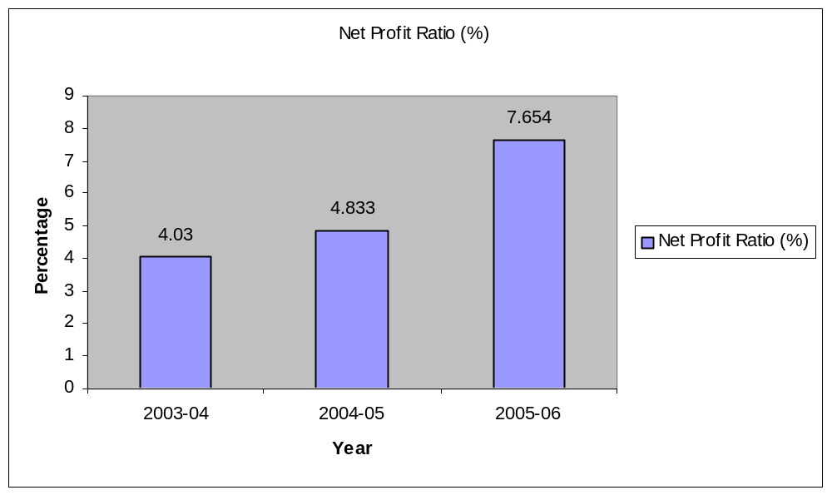

Interpretation: The net profit of BDKPC Pvt. Ltd. in 2003-04 is 4.030%, and in the year 2004-05 it is increased to 4.833% and again in the year 2005-06 it is increased to 7.654%. Therefore Net Profit Ratio is Satisfactory. Indicates the company’s efficient management in manufacturing, administrating and selling the products.
The BDKPC Pvt. Ltd. is having an advantageous position and economic condition of the firm is good.

3.OPERATING PROFIT RATIO
This ratio is calculated as follows:
= EBIT
______ * 100
Net sales
OPERATING PROFIT RATIO
(Amount in Lakhs)
Year | 2003-04 | 2004-05 | 2005-06
EBIT | 63.52 | 144.51 | 368.59
Net Sales | 1452.57 | 2026.13 | 2689.94
Operating Profit Ratio (%) | 4.372 | 7.132 | 13.702
SOURCE: ANNUAL REPORTS OF COMPANY

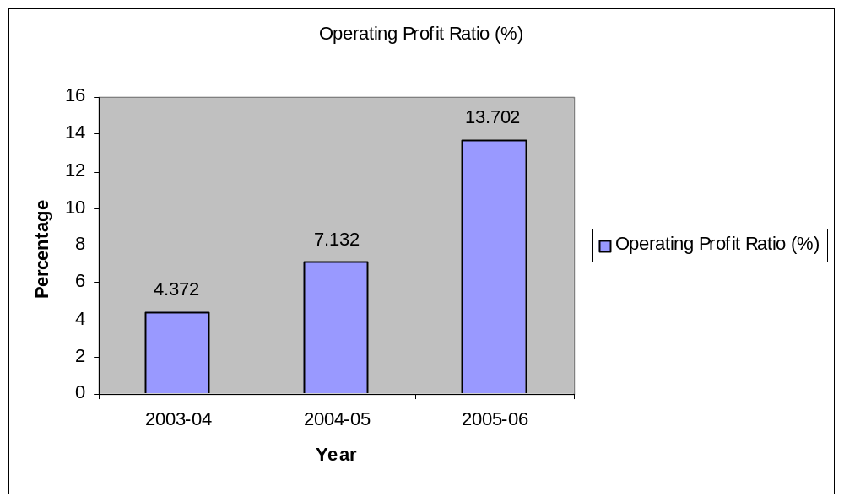

Interpretation: This ratio of Operating Profit in BDKPC Pvt. Ltd., in the year 2003-04 is 4.372% and it is increased in the year 2004-05 to 7.132% and further it is increased to 13.702% in the year 2005-06. The ratio is increased for all the three subsequent years. This ratio indicates the company’s operating performance is good in all the three years.

4. RETURN ON INVESTMENT (ROI):
It is also called as overall profitability ratio or Return on capital employed (ROCE) Ratio. This ratio is the broadest measure of the overall performance of business firm. It indicates the percentage of return on the total capital employed in the business. The higher ratio, the more efficient use of the capital employed. It is calculated on the bases of the following:
ROI = Operating Profit OR PBIT
_______________ * 100 ________________ * 100
Capital employed Capital employed

RETURN ON INVESTMENT RATIO
(Amount in Lakhs)
Year | 2003-04 | 2004-05 | 2005-06
PBIT | 63.52 | 144.51 | 368.59
Capital Employed | 689.46 | 787.40 | 1185.00
Return On Investment Ratio (%) | 9.213 | 18.352 | 31.10
SOURCE: ANNUAL REPORTS OF COMPANY

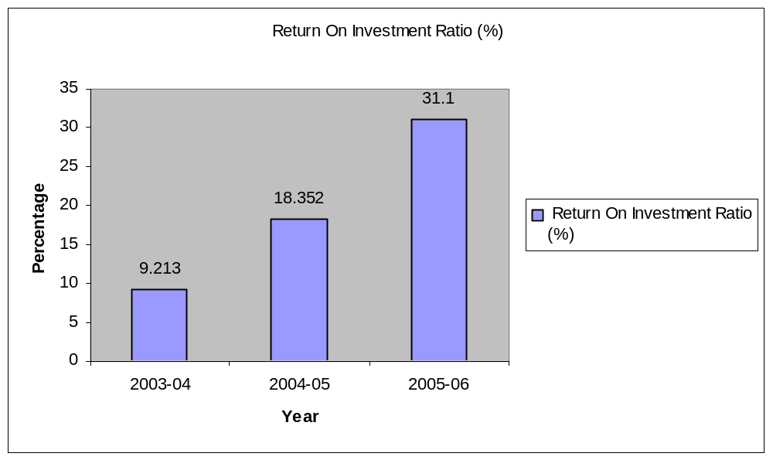

Interpretation: In 2003-04 the ROI was 9.213 %, in the year 2004-05 it increases to 18.352 %, and in the year 2005-06 it moves to 31.10 %. The return on investment ratio is increased in all the 3 years. It means here the company had use the capital employed efficiently.

5. RETURN ON EQUITY (ROE) / NET WORTH
Return on Equity is calculated to see the profitability of owner’s investment.
Return on Equity = PAT
____________________________ * 100
Shareholder’s Equity or Net worth
Return on Equity indicates how well the firm has used the resources of owners. This ratio reflects the extent to which this objective has been accomplished. This ratio is of great interest to the present as well as the prospective shareholders and also of great concern to management, which has the responsibility of maximizing the owner’s welfare.

RETURN ON EQUITY
(Amount in Lakhs)
Year | 2003-04 | 2004-05 | 2005-06
PAT | 58.52 | 97.93 | 205.89
Net Worth | 441.75 | 539.69 | 745.51
Return On Equity Ratio (%) | 13.247 | 18.145 | 27.617
SOURCE: ANNUAL REPORTS OF COMPANY

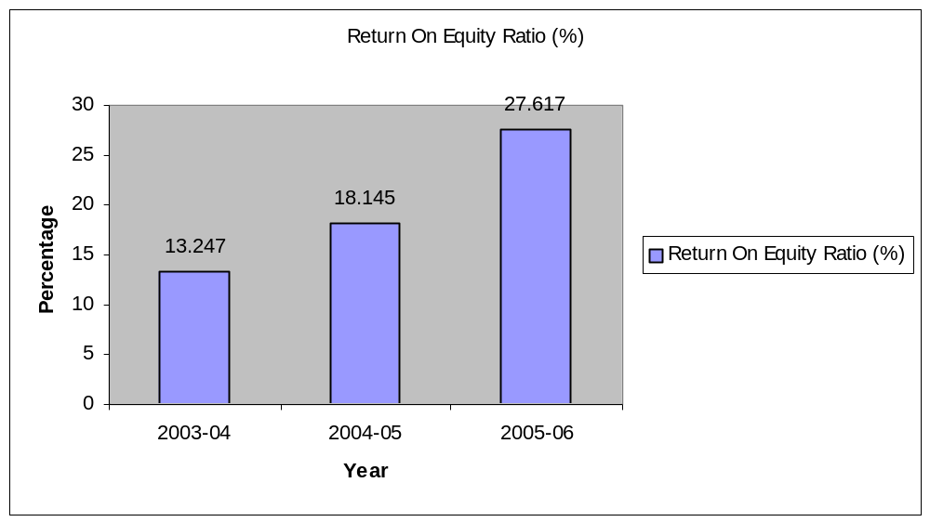

Interpretation: In 2003-04 the return on investment was 13.247%. It increases to 18.145% in the year 2004-05. And it further increases to 27.617%. It indicates that management has used the resources of owners very effectively. Therefore in the year 2005-06 company incurred profit. The ratio is high. In addition, there is substantial increase in all the 3 years.

6. RETURN ON TOTAL ASSETS (ROTA)
This ratio is compared to know the ‘Productivity of the total assets’. There are two methods of computing Return on Total Assets
1. ROTA= PAT
___________ * 100
Total Assets

2. ROTA= PAT + Interest
_______________ * 100
Total Assets

RETURN ON TOTAL ASSETS
(Amount in Lakhs)
Year | 2003-04 | 2004-05 | 2005-06
PAT | 58.52 | 97.93 | 205.89
Total Assets | 1146.84 | 1174.41 | 1649.72
Return On Total Assets Ratio (%) | 5.102 | 8.338 | 12.480
SOURCE: ANNUAL REPORTS OF COMPANY

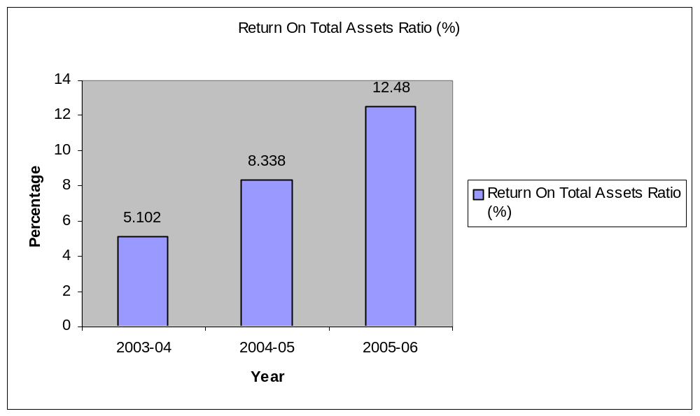
Interpretation: In 2003-04 the return on assets was 5.102 %. It increases to 8.338 % in the year 2004-05. And it further increases to 12.480 %. It indicates that management has used assets very effectively. Therefore in the year 2005-06 company incurred profit. The ratio is high. In addition, there is substantial increase in all the 3 years.

7.EARNING PER SHARE (EPS):
It measures the profit available to the equity shareholders on a per share basis, that is amount that they can get on every share held. It is calculated by dividing the profits available to the shareholders by the number of the outstanding shares. The profits available to the ordinary shareholders are represented by net profit after taxes and preference dividend. The overall profitability can also be judged by calculating EPS. EPS is calculated by following formula:
EPS = PAT
___________________
Number of Equity Shares
EARNINGS PER SHARE
(Amount in Lakhs)
Year | 2003-04 | 2004-05 | 2005-06
PAT | 58.52 | 97.93 | 205.89
NO. Of Equity Shares | 2999510 | 2999510 | 2999510
Ratio | 1.951 | 3.265 | 6.865
SOURCE: ANNUAL REPORTS OF COMPANY

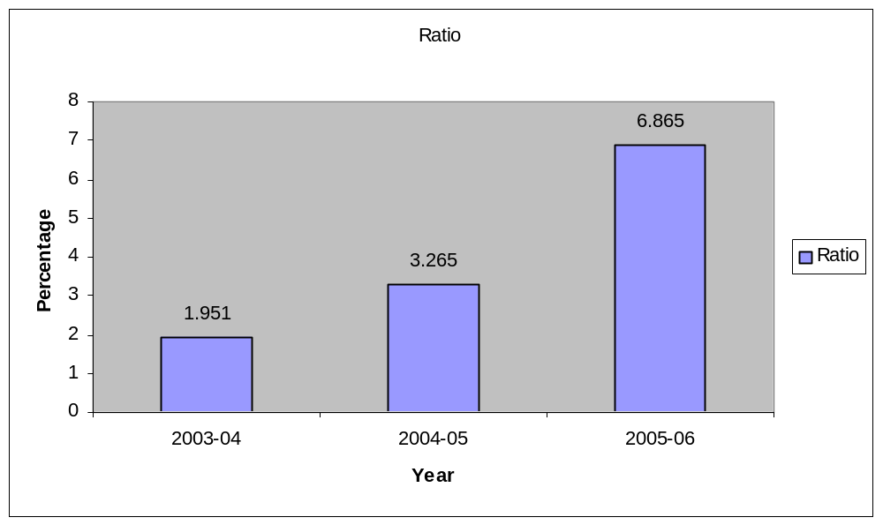
Interpretation: EPS of Company in 2003-04 is Rs. 1.951, which increases to Rs. 3.265 in the year 2004-05. And further it increases to Rs. 6.865 in the year 2005-06 due to increase in profit, EPS is increased.

NOTES:
- Net sales= Gross Sales –Excise
- COGS= (Op. stock +Purchases of products +Consumption of Raw materials & components + consumption of stores spares, tools + freight, transportation, port charges + Power and fuel. ) – Closing Stock..
- Gross Profit= Net Sales – COGS
- Total Assets= Fixed Assets + Current Assets.
- Net Worth= Capital + Reserves and surplus.
- COGS= Cost Of Goods Sold

ANALYSIS
OF
TURNOVER RATIOS
OF THE
COMPANY

TURNOVER / ACTIVITY RATIOS OF THE COMPANY

Introduction:
Activity ratios are employed to evaluate the efficiently with which the firm manages and utilizes its assets. These ratios are also called as turnover ratio. Therefore they indicate the speed with which assets are being converted / turned over in to sales.
Thus an activity ratio involves relationship between sales and assets. A proper balance between sales and assets generally reflects that assets are managed well.
In other words, turnover ratio indicates the efficiency with which the capital employed is rotated in the business.
Higher the ratio of rotation, the greater will be the profitability
DIFFERENT TURNOVER RATIOS:
- Inventory stock turnover Ratio
- Debtors (Accounts Receivable) Turnover Ratios.
- Creditors (Account Payable) Turnover Ratios.
- Fixed Assets turnover Ratio
- Current Assets turnover Ratio

- INVENTORY / STOCK TURNOVER RATIO (ITR/STR).
It indicates the efficiency of firm in producing and selling its products. High Ratio is good from the view point of liquidity and vice versa.
A low ratio would signify that inventory does not sell fast and stably in the warehouse for a longtime.

It is calculated as follows:
Cost of Goods Sold OR Sales (If there is no opening stock)
________________ __________
Avg. Inventory Closing Stock

Hence Avg. Inventory = Opening Stock + Closing Stock
____________________________
2
Avg. Inventory is calculated by taking stock levels of raw materials, working process and finished goods at the beginning of year & at the end of the year & that is divided by two
INVENTORY TURNOVER RATIO
(Amount in Lakhs)
Year | 2003-2004 | 2004-2005 | 2005-2006
COGS | 1028.18 | 1465.02 | 1891.77
Average Inventory | 282.01 | 237.09 | 224.34
Inventory Turnover Ratio | 3.645 | 6.179 | 8.432
SOURCE: ANNUAL REPORTS OF COMPANY

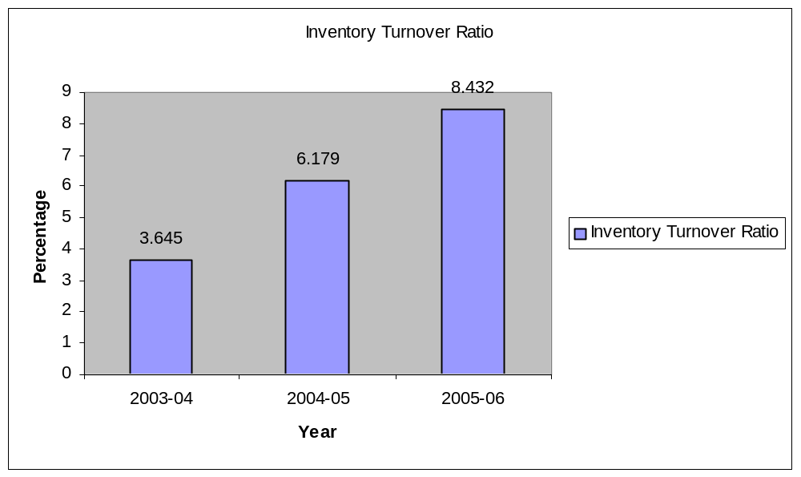

INVENTORY CONVERSION RATIO
Year | 2003-04 | 2004-2005 | 2005-2006
No. of days in year | 365 | 365 | 365
ITR | 3.645 | 6.179 | 8.432
Days | 100.137 | 59.071 | 43.284
SOURCE: ANNUAL REPORTS OF COMPANY
Interpretation:
The STR/ ITR are high in all three years. And Stock conversion is very fast because company takes 101 days in 2003-04. It decreases in 2004-05 to 60 days. And in 2005-06 it is 44 days. It indicates that conversion ratio is very fast. And the company’s utilization of inventories in generating sales is good.

- DEBTORS TURNOVER RATIO:
Debtors constitute an important constituent of current assets and therefore the quality of debtors to great extent determines that firm’s liquidity. There are two ratios. They are:
  - Debtors turnover Ratio
  - Debtors collection period Ratio

Debtor’s turnover can be calculated by dividing total sales by balance of debtors.
Debtors turnover = Sales
______
Debtors
Higher the ratio is better, since it indicate that debts are being collected more promptly

DEBTOR’S COLLECTION PERIOD:
This ratio indicates the extent to which the debts have been collected in time. It gives the average debt collection period. The higher is the turnover ratio and shorter is the average
collection period the better is the trade credit management and the better is the liquidity of debtors, as short collection period and high turnover ratio imply prompt payment on
the part of debtors. On the other hand, low turnover ratio and long collection period reflects that payments by debtors are delayed.
Debtors Collection Period = No. of days
__________
DTR

DEBTOR’S TURNOVER RATIO
(Amount in Lakhs)
Year | 2003-04 | 2004-2005 | 2005-2006
Net Sales | 1452.57 | 2026.13 | 2689.94
Debtor’s | 291.98 | 262.39 | 515.56
Debtors Turnover Ratio | 4.974 | 7.721 | 5.2175
Debtors collection Period (Days) | 73.38 | 47.26 | 70.79
SOURCE: ANNUAL REPORTS OF COMPANY

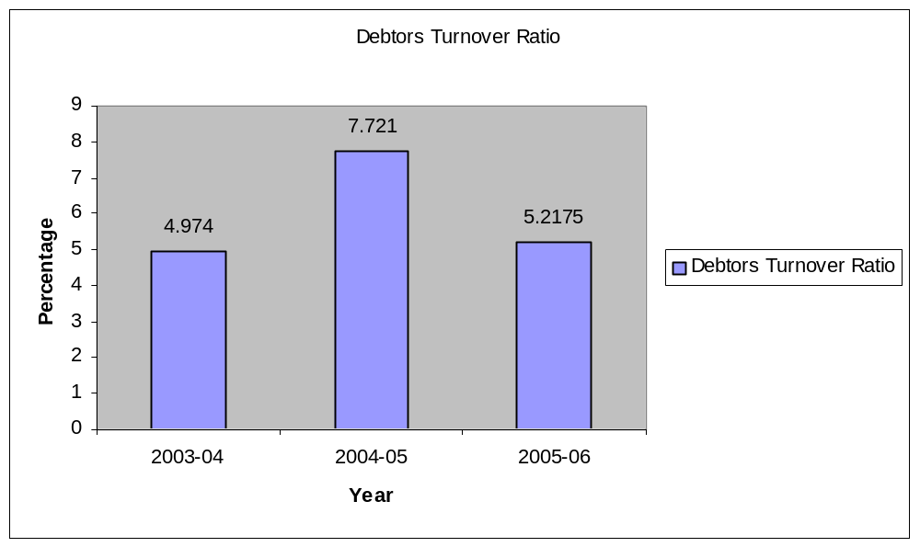
Interpretation: The ratio is fluctuating between the range of 4.974 to 7.721. In the year 2003-04 ratio is 4.974 times which is increased to 7.721 times in the year 2004-05. But in the year 2005-06 ratio is decreased to 5.2175. And hence the debtor’s collection period is 74 days in 2003-04, and decreased to 47 days. But in the year 2005-06 it again increased to 71 days although it is satisfactory as compared to the company’s credit policy.

3) CREDITOR’S TURNOVER RATIO:
It indicates the speed with which the payment for credit purchases is made to creditors. This ratio is calculated as follows:
=Credit Purchases
______________
Avg. creditor

It details regarding credit purchases, opening and closing A/c payable have not been given, and the ratio may be calculated as follows:
= Total purchase
_____________
Creditors
CREDITORS TURNOVR RATIO
(Amount in Lakhs)
Year | 2003-04 | 2004-05 | 2005-06
Total Purchases | 956.61 | 1364.27 | 1808.25
Creditors | 291.98 | 262.39 | 515.56
Creditors Turnover Ratio | 3.276 | 5.199 | 3.507
Days | 111.416 | 70.205 | 104.077
SOURCE: ANNUAL REPORTS OF COMPANY

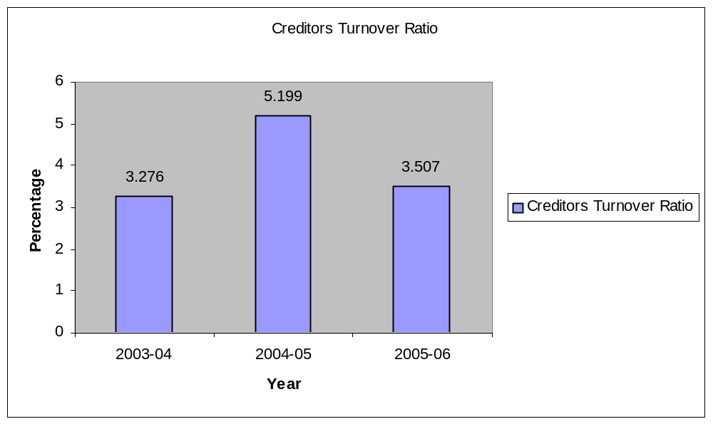
Interpretation: Credit paid after 112 days in the year 2003-04, which is decreased to 71 days in the year 2004-05, again in the year 2005-06 it is increased to 105 days. Which indicating they are enjoyed more credit period in 2003-04 and 2005-06 as compared to the year 2004-05.

4) FIXED ASSETS TURNOVER RATIO
This ratio indicates the extent to which the investments in fixed assets contributed towards sales. If compared with a previous period, it indicates whether the investment in fixed assets has been judicious / not.
The ratio is calculated as follows:
= Cost of Goods Sold
_________________
Net Fixed Assets

FIXED ASSETS TURNOVER RATIO
(Amounts in Lakhs)
Year | 2003-04 | 2004-05 | 2005-06
COGS | 1028.18 | 1465.02 | 1891.77
Fixed Assets | 375.02 | 370.51 | 414.18
Fixed Assets Turnover Ratio | 2.741 | 3.954 | 4.567
SOURCE: ANNUAL REPORTS OF COMPANY
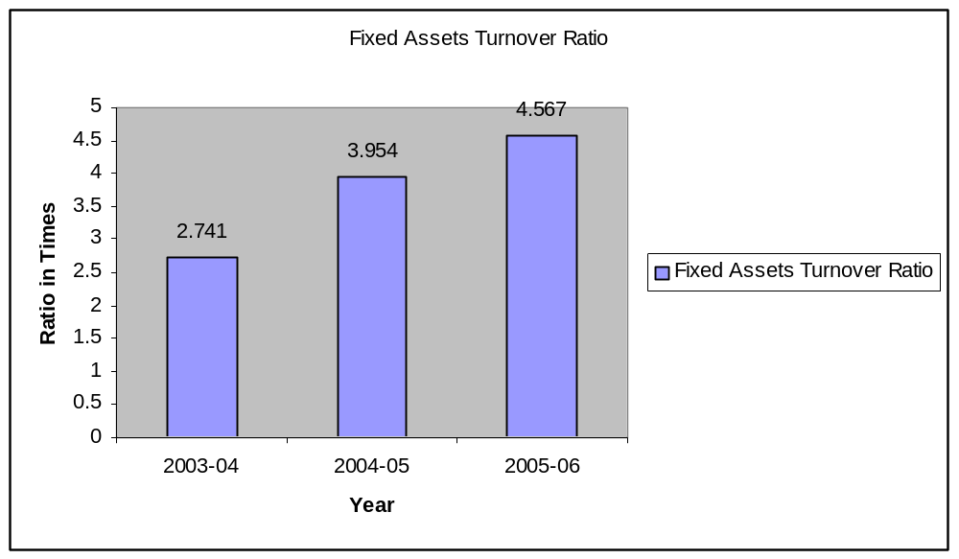
Interpretation: In all the three years the fixed assets turnover ratio is increased. Which indicates that fixed assets are properly utilized i.e. there is a better efficiency in utilization of fixed assets.

5) CURRENT ASSETS TURNOVER RATIO:
This ratio indicates the extent to which the investment in current assets contributed towards sales. If the ratio is compared with a previous period, it indicates whether the investment ion current assets has been judicious or nor. The ratio is calculated by dividing the cost of goods sold to Avg. current assets. The ratio is calculated as follows:
= Cost of Goods Sold
__________________
Current Assets
CURRENT ASSETS TURNOVER RATIO
(Amounts in Lakhs)
Year | 2003-04 | 2004-05 | 2005-06
COGS | 1028.18 | 1465.02 | 1891.77
Current Assets | 727.32 | 762.73 | 1188.67
Current Assets Turnover Ratio | 1.413 | 1.920 | 1.591
SOURCE: ANNUAL REPORTS OF COMPANY

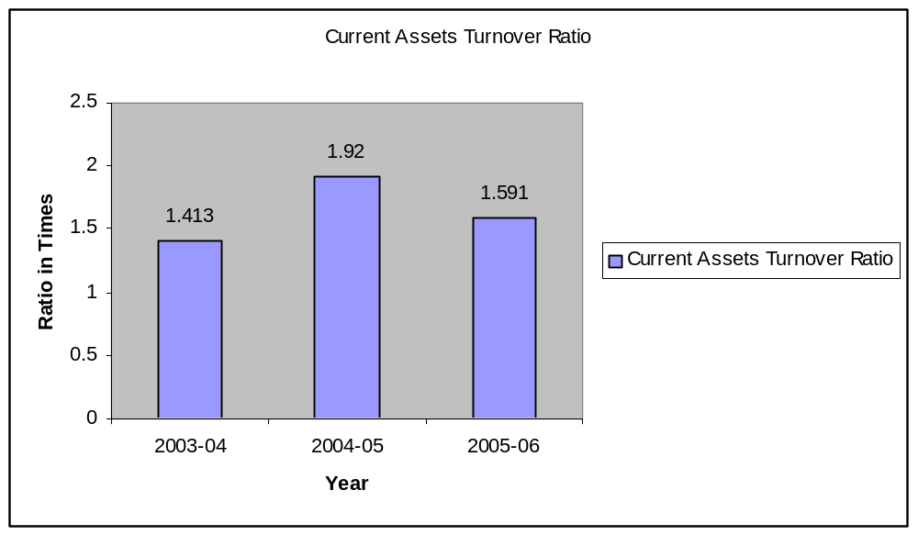
Interpretation: Current assets turnover ratio is increased in first two years but in
2005-06 there is a slight decrease in the ratio due to the increase of current assets. But it is more than one in all cases. It indicates that the current assets are promptly invested towards making sales.

ANALYSIS
OF
FINANCIAL RATIOS
OF THE
COMPANY

FINANCIAL RATIOS OF THE COMPANY
Introduction:
Financial ratios indicate about the financial position of the company. A company is deemed to be financially sound, if it is in position to carry on its business smoothly and meet all its obligations both long- term as well as short- term without strain. Thus, company financial position has to be judged from two angles long- term as well as short- term.
- Financial Ratio:
  - Current Ratio
  - Quick / Acid test / Liquid Ratio.
  - Absolute liquid / Cash Ratio

- Leverage Ratio :
- Debt ratio
- Debt equity Ratio
- Proprietary Ratio

LIQUIDITY RATIO
Liquidity ratios may be defined as financial ratio, which thorough tight on short term slovenly of firm.
Liquidity Ratio measures the ability of the firm to meet its current obligations. Liquidity ratio needs establishing a relationship between cash and other current assets to current obligations to provide quick measures of liquidity. A firm should ensure that it doesn’t

suffer from lack of liquidity and also that it does not have excess liquidity. Failure of a company to meet its obligations due to lack of sufficient liquidity, will result in a poor creditworthiness, loss of creditor’s confidence.
Liquidity is perquisite for the survival of firm. The short-term creditors of firm are interested in short-term solvency / liquidity of firm. But liquidity implies from the viewpoint utilization of funds of the firm, that funds are idle or they even very little.
So liquidity ratio measure ability of a firm to meet its short- term obligations and reflect short- term financial strength / solvency of firm.
1) CURRENT RATIO:
This ratio is an indicator of firm’s commitment to meet its short- term liabilities. Higher ratio, better the coverage, 2:1 ratio is treat as standard ratio. This ratio is also called as solvency / working capital ratio.
The current ratio is the ratio of the current assets and current liabilities. It is calculated by dividing current assets by current liabilities.
Current Ratio= Current assets
Current liabilities
The current ratio is a measure of short- term solvency of the company. It indicates the rupee of current assets available for each rupee of current liability. The higher the current ratio the larger the amount of rupees available per rupee of current liability and the greater the safety of the short- term creditors. This margin of safety to the creditors is essential due to the unevenness of the flow of funds through current assets and current account. The current liabilities can be settled by making the payment whereas the current assets available to liquidate them are subject to shrinkage of various reasons like

obsolescence of inventory, bad debts, and unexpected losses and so on. Thus current ratio represents the short- term liquidity “Buffer”.
CURRENT RATIO
(Amount in Lakhs)
Year | 2003-04 | 2004-2005 | 2005-2006
Current Assets | 727.32 | 762.73 | 1188.67
Current Liabilities | 418.51 | 387.04 | 433.12
Current Ratio | 1.737 | 1.970 | 2.744
SOURCE: ANNUAL REPORTS OF COMPANY
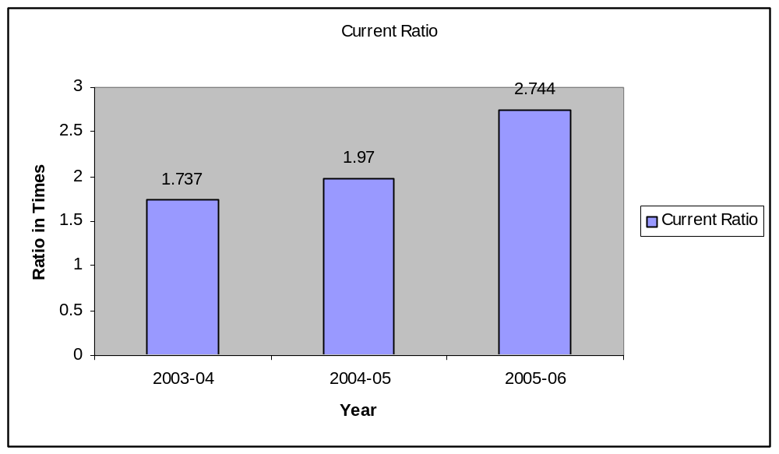

Interpretation: The ratio is quite good in first two years, when compared with the conventional standard 2. But in the year 2005-06 current ratio is high which indicates there will be an excess liquidity in the year 2005-06, which is quite dangerous hence company should minimize its investments in current assets.

2) QUICK / ACID TEST / LIQUID RATIO:
Liquid ratio is indication of availability of quick assets to honor its immediate claims.
Higher the ratio betters the coverage. And the standard ratio is 1:1.
An asset is liquid if is can be converted into cash immediately without loss of value. Hence cash is most liquid assets after assets which are considered to be relatively liquid are; Debtor’s balance, marketable securities etc. inventories considered to be less liquid therefore they require some time form relishing into cash and their value also has tendency to fluctuate.
The ratio is calculated as follows:
= Quick Assets
________________________
Current Liabilities
QUICK / ACID TEST / LIQUID RATIO
(Amount in Lakhs)
Year | 2003-04 | 2004-2005 | 2005-2006
Quick Assets | 363.36 | 498.25 | 787.89
Current Liabilities | 418.57 | 387.04 | 433.12
Quick Ratio | .868 | 1.287 | 1.819
SOURCE: ANNUAL REPORTS OF COMPANY

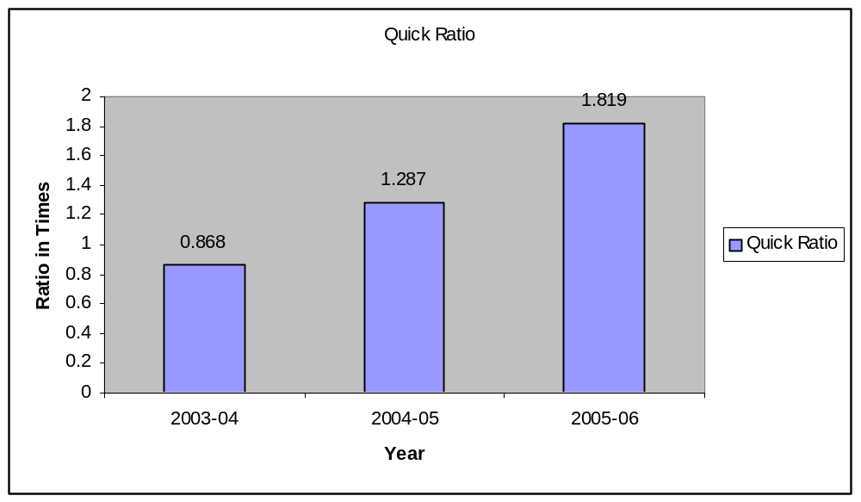
Interpretation: The ratio is moderate in first two years when compared with the conventional standard 1:1, which is quite satisfactory. But in the year 2005-06 the ratio is increased and it is high indicates the company has the excess liquidity which is dangerous.

3) CASH / ABSOLUTE LIQUID RATIO:
It calculated as follows:

= Cash + Bank Balance
_____________________
Current Liabilities
Here, trade investment; marketable securities are equivalent of cash. And therefore they may be included in the computation of cash ratio. The standard rate for this ratio 0.5:1. This ratio also indicates liquidity position and company and firms commitment to meet its short -term liabilities.

CASH / ABSOLUTE LIQUID RATIO
(Amount in Lakhs)
Year | 2003-04 | 2004-2005 | 2005-2006
Cash +Bank Balance | 17.59 | 171.37 | 201.86
Current Liabilities | 418.57 | 387.04 | 433.12
Cash Ratio | .042 | .442 | .466
SOURCE: ANNUAL REPORTS OF COMPANY

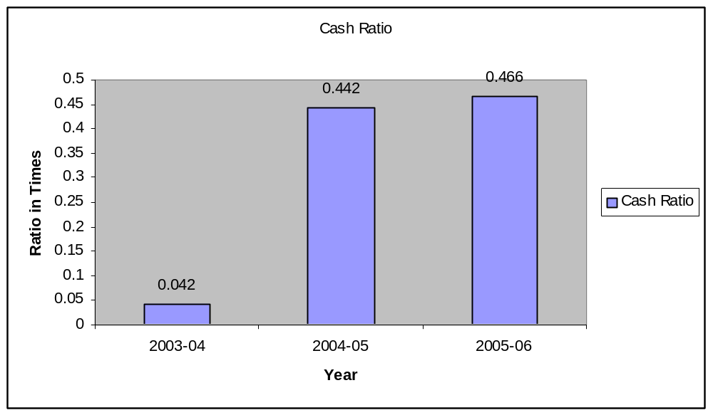

Interpretation: Cash ratio is much less than the conventional standard of 0.5:1 in
2003-04. But in next two years it is increased and nearer to .5. It indicates that liquidity position of the company is increased and hence the firm has enough cash and bank balances to meet its short-term liabilities.

LEVERAGE RATIO
LEVERAGE RATIO is also called as capital structure ratio. It relates to the study of various types of capital structure of firm. The long- term solvency of a company can be examined by using leverages or capital structure ratios. These ratios are for long-term creditors to judge the long-term financial strength of the company. The aspects that are mainly considered for this are:
  - Ability to repay the principal when due and
  - Regular payment of the interest.
THE DIFFERENT LEVERAGE RATIO ARE:
- Debt Ratio
- Debt Equity Ratio
- Proprietary Ratio
1) DEBT RATIO:
It expresses out side liabilities i.e. both long -term and short-term in relation to total capitalization of firm.
It is calculated as follows:
= Total Debt
______________
Total Assets
Generally creditors will prefer low debt ratio, since lower the ratio, higher the caution against creditors losses in the event of liquidation.
Conversely, owners may prefer high debt ratio either
- To magnify earnings or
- Because issuing new share means giving up some degree of control

But a high debt ratio may create problem with respect to future financing since creditors may reluctant to lend the firm more money unless equity base is increased.
DEBT RATIO
(Amount in Lakhs)
Year | 2003-04 | 2004-2005 | 2005-2006
Total Debt | 291.98 | 262.39 | 515.56
Total Assets | 1146.84 | 1174.41 | 1649.72
Debt Ratio | .254 | .223 | .312
SOURCE: ANNUAL REPORTS OF COMPANY
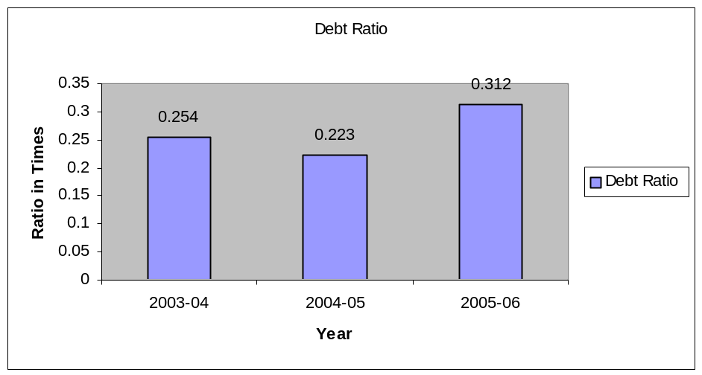

Interpretation: Ratio is fluctuating in between the range of .223 to .312 during the period of study. In the year 2003-04 the ratio is .254 and it is decreased to .223 in 2004-05. Again the ratio is increased to .312 in the year 2005-06. Which indicates that lenders are financing one-third of total assets and remaining two- third is financed by owners of

the firm, indicating that firm is more dependent on owners fund to meet its long-term liabilities.
2) DEBT-EQUITY RATIO
It measures the relation between debt and equity in the capital structure of the firm. In other word, This ratio shows the relationship between the borrowed capital and owner’s capital. This ratio shows relative claim of the creditors and shareholders against the assets of the company.
It is expressed as:
= Long-term Debt
__________________
Shareholders Equity
Generally higher the ratio greater is the possibility of increasing the ROR to equity & vice versa.
A high debt equity ratio may be adopted to take advantage of cheaper debt capital.
The ratio indicates the extent to which the firm depends upon out side for its existence. The ratio provides margin of safety to the creditors. It tells owners the extent to which they can gain benefits of maintaining control with a limit investment.
DEBT-EQUITY RATIO
(Amount in Lakhs)
Year | 2003-04 | 2004-2005 | 2005-2006
Borrowings | 286.60 | 247.71 | 439.49
Total Capital Employed | 689.46 | 787.40 | 1185.00
Debt-Equity Ratio | .415 | .314 | .370
SOURCE: ANNUAL REPORTS OF COMPANY

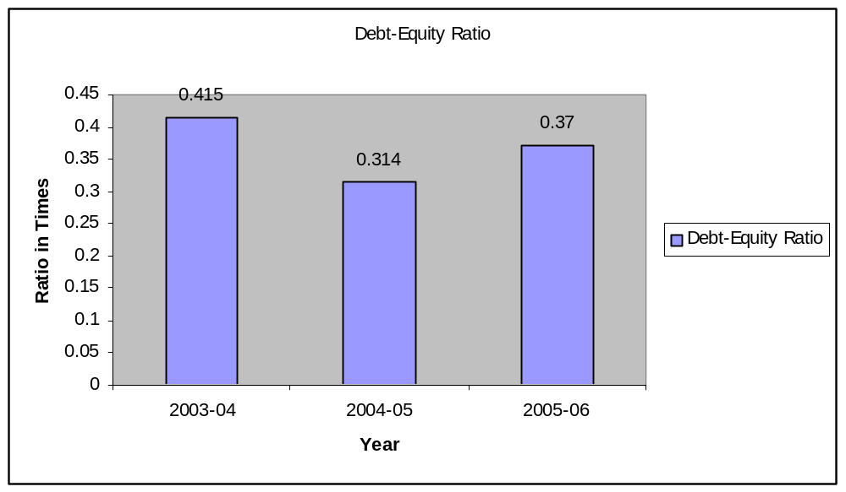

Interpretation: The ratio is fluctuating in between the range of .314 to .415 during the period of study. Which indicates that the Company depends more on internal sources than on external sources i.e. it indicates that company depends upon insiders i.e. on shareholders fund & and it also indicates that company is having sound financial position
.
3) PROPRITORY RATIO:
It establishes relationship between the propitiator or shareholders funds & total tangible assets.
It may be expressed as:
Proprietary Ratio=Proprietor’s Funds
Total Assets
The ratio indicates properties stake in total assets. Higher the ratio lowers the risk and lower the ratio higher the risk. Debt –equity ratio & current ratio affects the proprietary ratio.

PROPRITORY RATIO
(Amount in Lakhs)
Year | 2003-04 | 2004-2005 | 2005-2006
Shareholders funds | 441.75 | 539.69 | 745.51
Total Assets | 1146.84 | 1174.41 | 1649.72
Proprietary Ratio | .385 | .4595 | .4519

SOURCE: ANNUAL REPORTS OF COMPANY

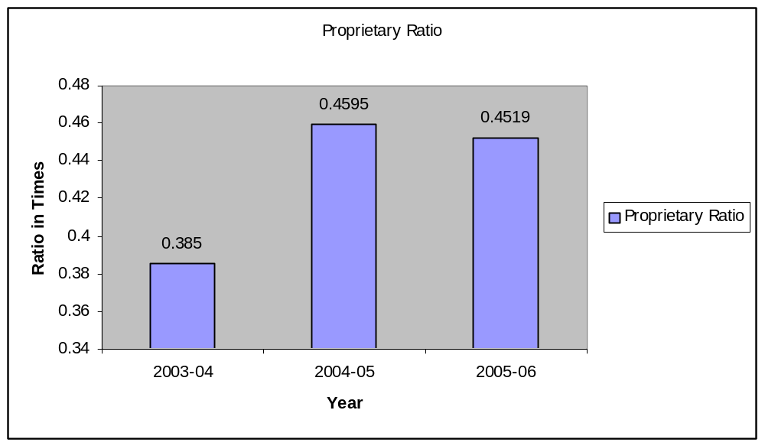

Interpretation: The ratio is .34 in the year 2003-04 and it is increased to .459 in
2004-05. But in the year 2005-06 the ratio is decreased to .451, which is quite normal hence negligible. It indicates that company’s dependence on shareholders fund is increasing in year by year. It shows that the financial position of the company is strong.

FINDINGS
- Gross profit and net profits are increased during the period of study, which indicates that company’s efficient management in manufacturing and trading operations.
- Profitability of the company is increasing in all the three subsequent years hence the return on investment, return on equity, return on assets and EPS is also increasing. Which indicates the company’s efficient management, in utilization of its resources to earn profit.
- Inventory turnover ratio of B.D.K.PC is increasing year by year, and hence the inventory conversation period is decreased in all the three years. Which indicates the inventories are converted into sales more rapidly during the period of study.
- Debtor’s collection period is fluctuating in between 47 days to 71 days during the period of study. This period is quite satisfactory as per the company’s credit policy.
- Creditors Turnover Ratio is moderate and the creditors’ payment period is also quite normal i.e. in the year 2005-06 creditors’ turnover ratio is 3.507% creditor payment period is 105 days. In 2005-06 firm enjoyed more credit period as compared to the year 2004-05.
- In all the three years the fixed assets turnover ratio is increased. Which indicates that fixed assets are properly utilized i.e. there is a better efficiency in utilization of fixed assets.
- Current assets turnover ratio is increased in first two years but in 2005-06 there is a slight decrease in the ratio due to the increase of current assets.

- In 2003-04 and 2004-05 financial ratios are moderate in nature. But in 2005-06 financial ratios are quite high i.e. current ratio is 2.744 and quick ratio is 1.819. In 2005-06 the liquidity position of the firm is quite high due to increase in investments in current assets.
- Cash ratio is good as compared to the standard ratio, which indicates the firm has enough cash and bank balances to meet its short-term liabilities.
- In 2005-06 the debt ratio is .312 and Debt-equity ratio is .37, which indicates that lenders are financing one-third of total capital and remaining two- third is financed by owners of the firm, indicating that firm is more dependent on owners fund to meet its long-term liabilities. Hence company is financially strong.
- Proprietary ratio is fluctuating in between the range .358 to .459. It indicates that company’s dependence on shareholders fund is increased year by year. It shows that the financial position of the company is increasing year by year.

.

SUGGESTIONS
- Since the B.D.K. Process Control Pvt. Ltd is earning the profit year by year, this will attracts many investors. Hence the company should concentrate on the expansion of the business and also they should contribute towards the social overheads for the welfare of the society.
- Company instead of depending fully on internal funds, it can also study the feasibility of borrowing funds from external sources, so it can still expand its production capacity considering the demand.
- Company should improve its credit policy for the better management of credit and to earn more profit.
- Liquidity position of the company is quite high; hence it should decrease investments in current assets. Hence they have to modify their credit policy to reduce debtors. And also they should think about these short-term investments in others such as expansion of the business.

CONCLUSION
From the analysis of financial statements it is clear that B.D.K. Process Control Pvt. Ltd. Have been incurring profit during the period of study. Although company has to still increase its credit policy and also decrease its investments in current assets. This will gives the new opportunities to the company like expansion of the business. With all these recommendations company can improve its profitability.

Contents:
- Bibliography

BIBILIOGRAPHY

- I.M. Pandey – Financial Management. Vikas Publishing House Pvt. Ltd.
- M.Y. Khan and P. K. Jain – Financial Management. Tata Megraw –Hill Publishing company Ltd. New Delhi.
- Khan and Jain – Management and Accounting. Himalaya publishing house Pvt. Ltd.
- Web Site: www.bdkindia.com

